1.1.4 AREA OF TRIANGLE
ALGORITHM
Step 1:- Start
Step 2:- Read the base of the triangle.
Step 3:- Read the height of the triangle.
Step 4:- Calculate the area using the formula
Step 5:- $\text{area}=0.5×\text{base}×\text{height}$
Step 6:- Display the area formatted to 2 decimal places.
Step 7:- Stop

Flowchart
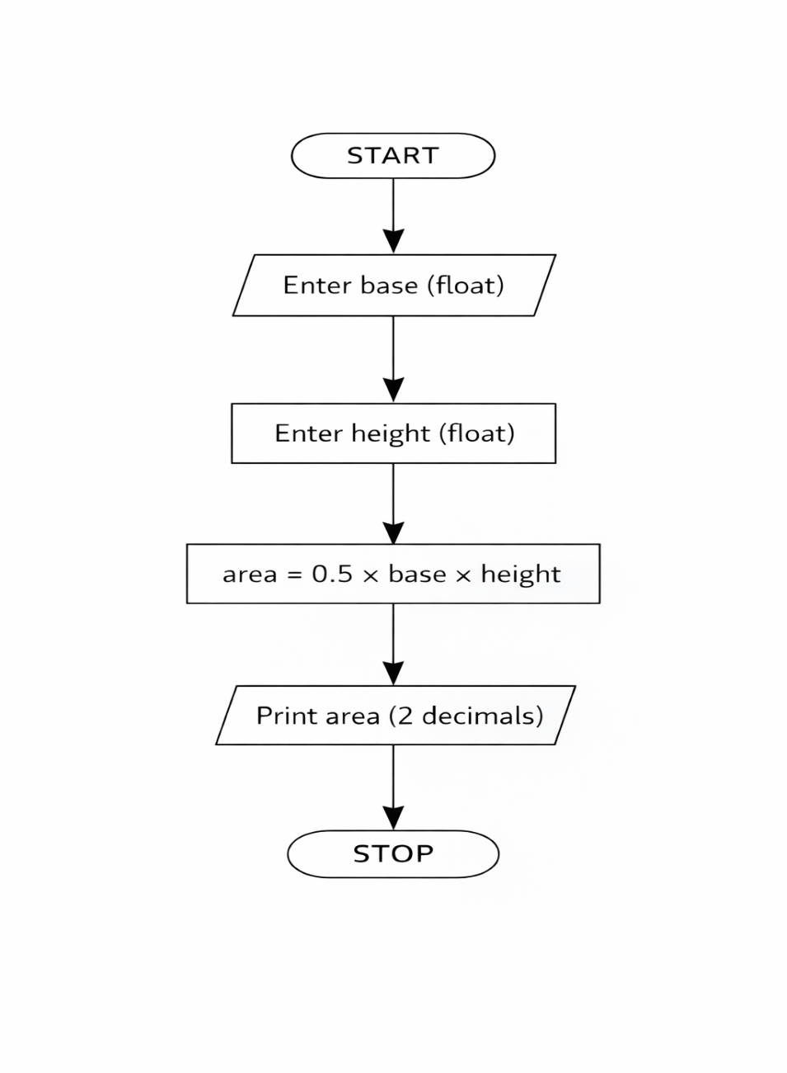
Python Code
base = float(input())
height = float(input())
area = 0.5 * base * height
print(f"{area:.2f}")

EXCECUTION

